**MySQL FOUNDATION PROJECT**

1. Write a SQL query to count the number of characters except for the spaces for each actor. Return the first 10 actors' name lengths along with their names.
2. List all Oscar awardees (Actors who received the Oscar award) with their full names and the length of their names.
3. Find the actors who have acted in the film ‘Frost Head.’
4. Pull all the films acted by the actor ‘Will Wilson.’
5. Pull all the films which were rented and return them in the month of May.
6. Pull all the films with ‘Comedy’ category.

**1)**

**SELECT first_name,last_name, LENGTH(first_name),length(last_name)**

**FROM actor limit 10;**

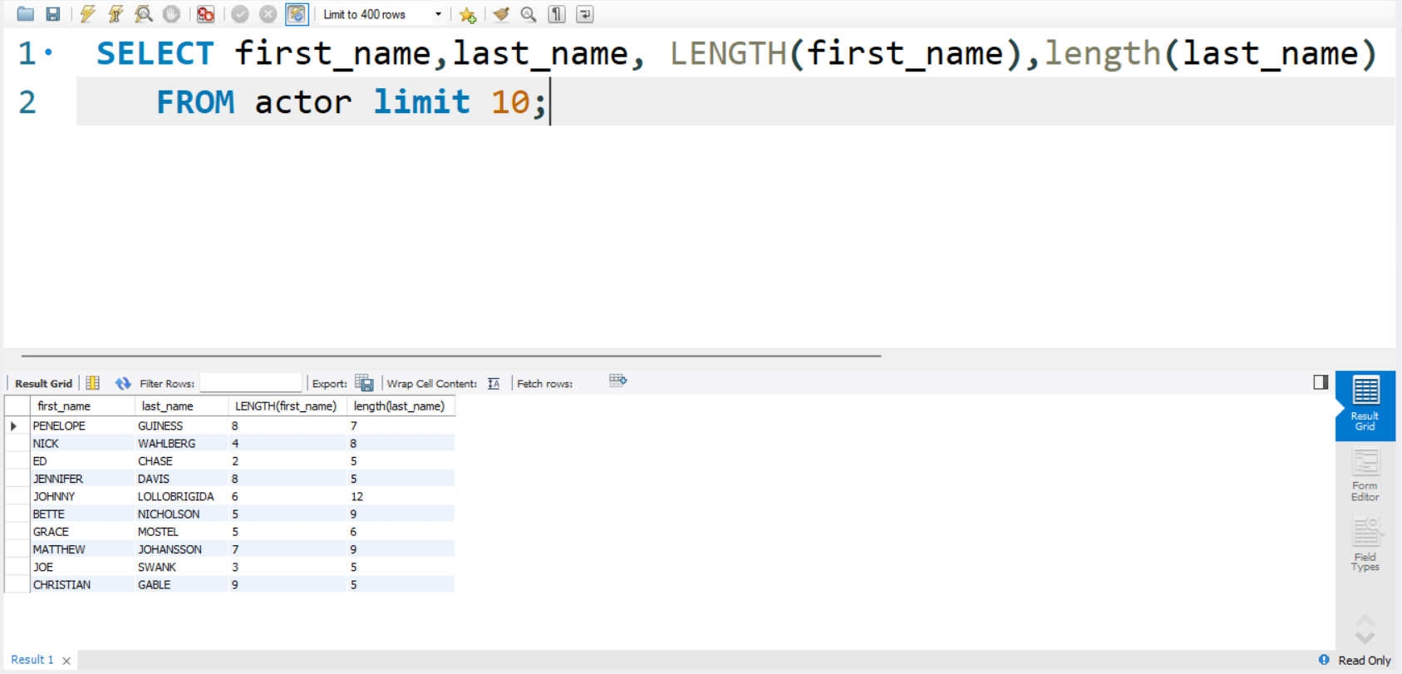

2)

SELECT CONCAT(actor.first_name, ' ', actor.last_name) AS full_name,

LENGTH(CONCAT(actor.first_name, ' ', actor.last_name)) AS full_name_length

FROM actor

INNER JOIN actor_award ON actor.actor_id = actor_award.actor_id

WHERE actor_award.awards = 'oscar';

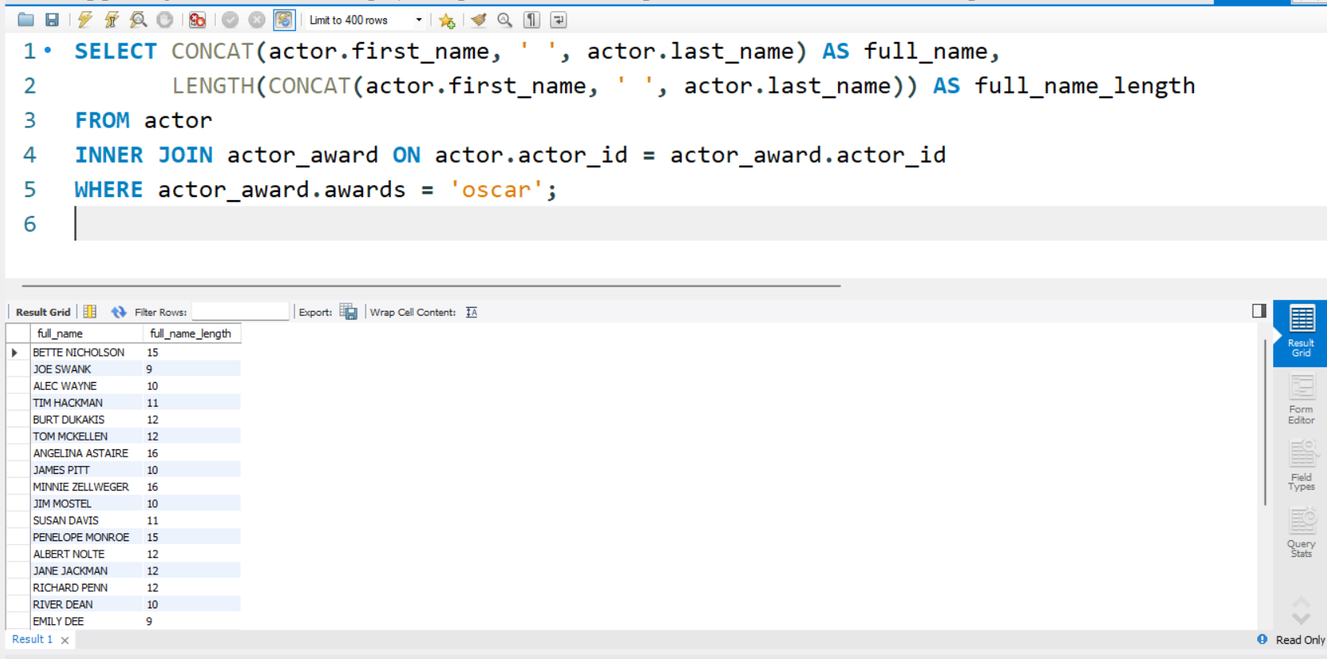

3)

SELECT CONCAT(actor.first_name, ' ', actor.last_name) AS full_name,

LENGTH(CONCAT(actor.first_name, ' ', actor.last_name)) AS full_name_length from film

inner join film_actor using (film_id) -- bridging

inner join actor using (actor_id)

where title = 'Frost Head';

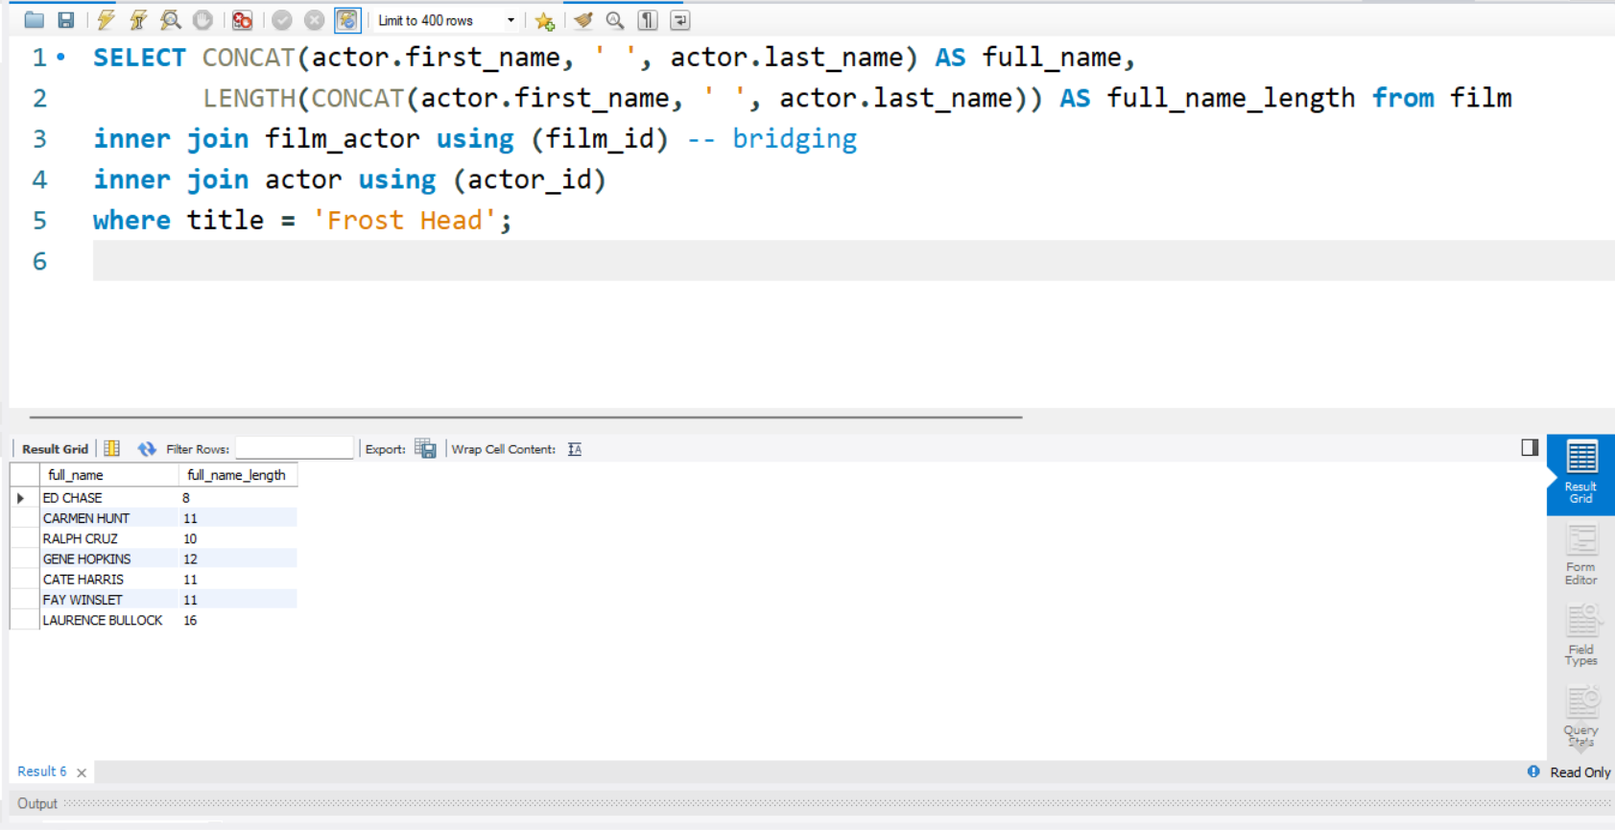

4)

SELECT CONCAT(actor.first_name, ' ', actor.last_name) AS full_name,title from film

inner join film_actor using (film_id)

inner join actor using (actor_id)

where first_name = 'Will'

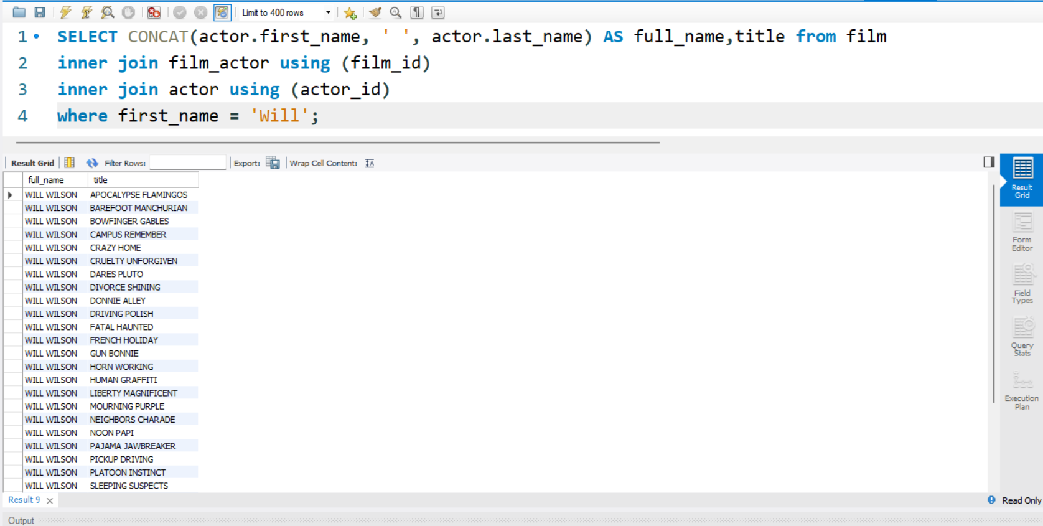

5)

SELECT film.title AS film_title, rental.rental_date, rental.return_date FROM rental

JOIN inventory ON rental.inventory_id = inventory.inventory_id

JOIN film ON inventory.film_id = film.film_id

WHERE MONTH(rental.rental_date) = 5 AND MONTH(rental.return_date) = 5;

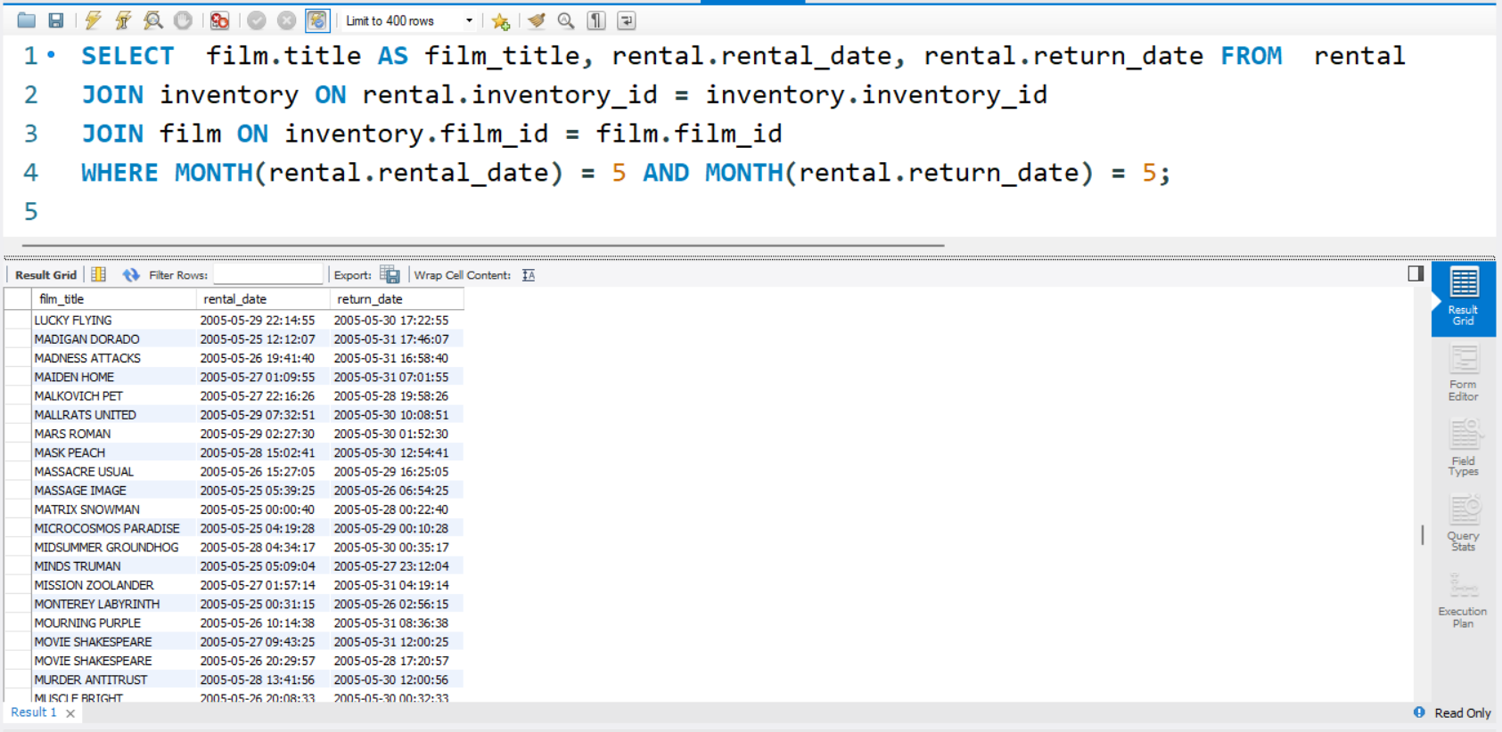

6)

select title, name from film

inner join film_category on film.film_id = film_category.film_id

inner join category on film_category.category_id = category.category_id where name = 'Comedy'

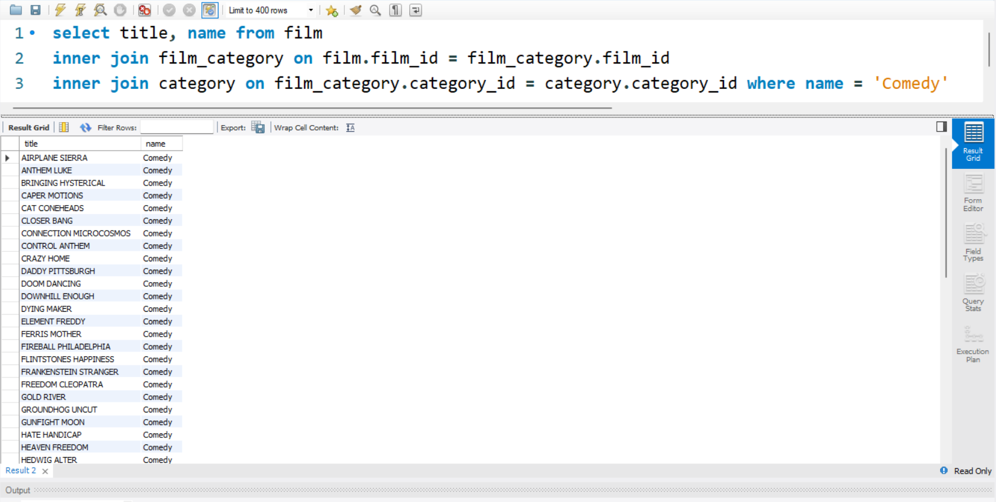

Data source : -

